SIMATS ENGINEERING
ASSESSMENT TOOL 2
COURSE NAME: Data Warehousing and Data Mining COURSE CODE: CSA1606
CO1-AT2 -Concept Map
Name: Ajay I
Reg No: 192421147
1) Decision Support Systems (DSS)
Task Description:
Construct a concept map
that explains how a Decision Support System (DSS) supports
organizational decision-making.
What your map must show:
1. Core components: Data, Model, User Interface
2. Types of DSS
3. Flow: Data → Analysis → Decision
4. Role in business decision-making
5. Real-world example linkage
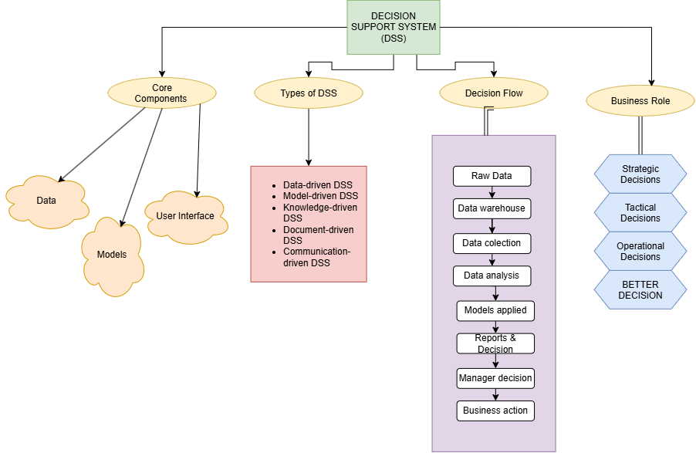
2) Concept Map 2: Operational Systems vs DSS
Task Description:
Develop a comparative concept map that clearly distinguishes Operational Systems (OLTP) and Decision Support Systems (OLAP).
What your map must show:
1. Definitions of OLTP and DSS
2. Differences (data type, purpose, users, processing)
3. Similarities and interactions
4. Real-time vs historical data
5. Example: systems (banking vs analytics)
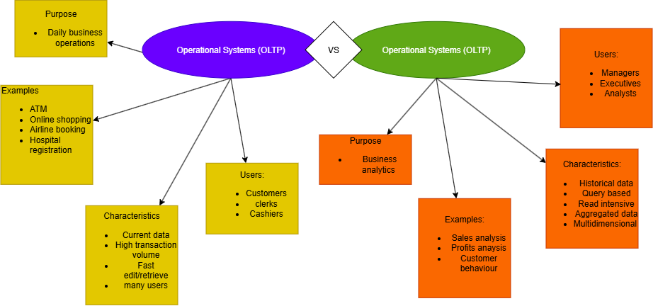

3) Concept Map 3: Architecture of Data Warehouse
Task Description:
Create a hierarchical concept map illustrating the architecture of a Data Warehouse.
What your map must show:
1. Data Sources → ETL → Data Warehouse → Data Marts
2. Metadata layer
3. Front-end tools (reporting, OLAP)
4. Data flow direction
5. Role of each layer

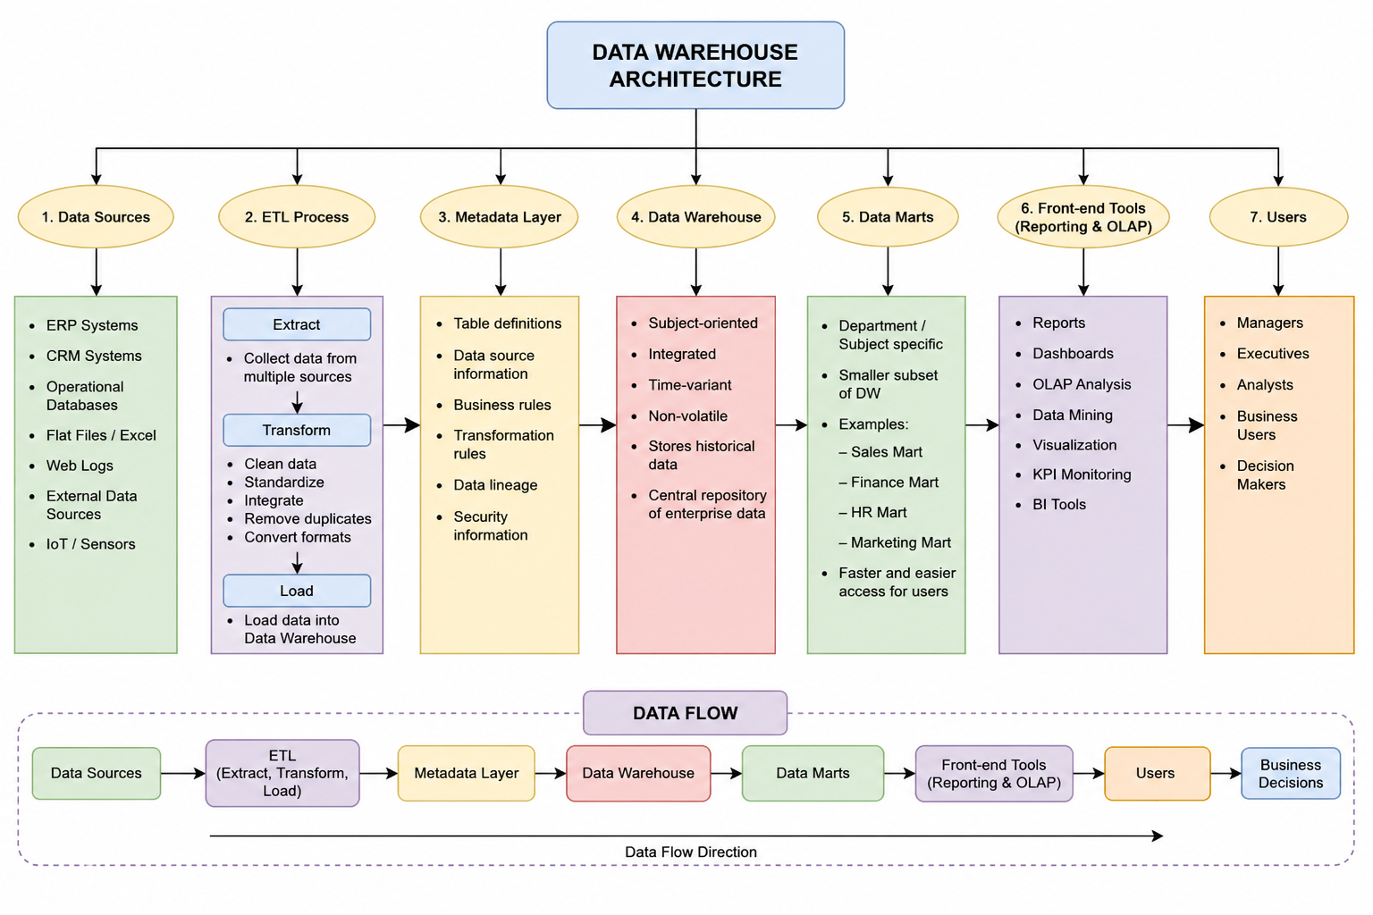

4) Concept Map 4: OLAP, Data Cubes & Dimensional Modeling
Task Description:
Design a concept map that connects OLAP operations, Data Cubes, and Dimensional Modeling techniques.
What your map must show:
1. Data cube structure (dimensions, measures)
2. OLAP operations (slice, dice, roll-up, drill-down)
3. Star schema and snowflake schema
4. Fact and dimension tables
5. Analytical usage

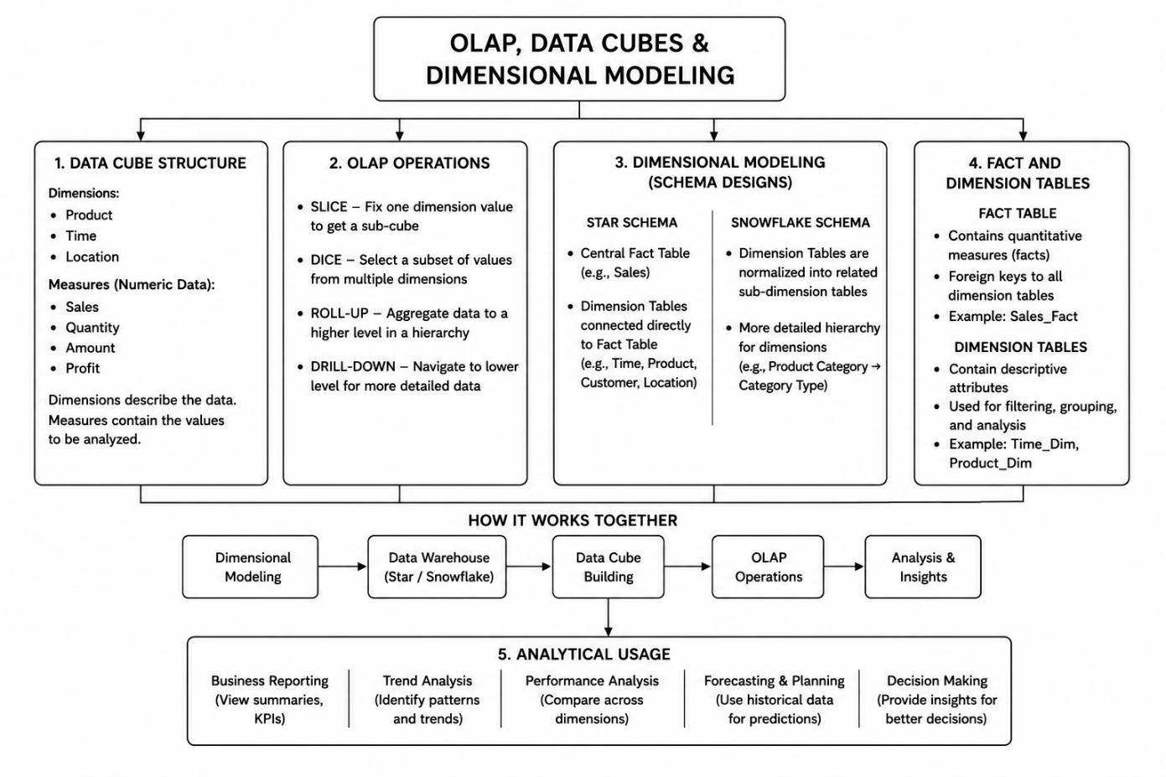

5) Concept Map 5: Query Processing & BI Tools (KNIME)
Task Description:
Construct a concept map
explaining how query processing integrates with BI tools, focusing on KNIME for reporting and OLAP applications.
What your map must show:
1. Query processing stages (Parsing, Optimization, Execution)
2. Role of BI tools
3. KNIME workflow structure
4. Data → Query → Visualization pipeline
5. OLAP application integration

